# **Website Review –**

# **Purpose and Component Features of Website**

**What is the difference between the Internet and WWW?**

What is the Internet?

The internet is a global network of networks all around the world. The computers on these networks can send each other data. [1]

What is WWW?

The WWW or World Wide Web is a collection of pages of information stored on the internet. [2]

Explain the differences

The WWW contains all the data and is what is seen by the user whereas the internet is the computers and infrastructure that stores the WWW, allows the user to navigate the WWW, and send data to and from user about the desired page.

**What is a public domain website?**

A website full of work form the public domain.

The public domain is work that is not protected by copywrite whether that is that the copywrite has expired, or the work never had it. This means the work is free to use for everyone, without permission.

**What is a Domain Names?**

The domain name is the name typed into the address bar of your brows. It is a URL (universal resource locator) and will look something like **something.something_else, e.g. Google.com** it is used to find the specific webpage instead of using the page’s ip address. It is made to make searching the internet easier to do as you could use strings of letters and numbers to find a specific page rather than having to use four numbers separated by full stops (123.12.1.276) to find the page.

**Web browser 1.0**

Only static html pages. Does not change based on what the user’s behaviour on the website. The data is stored in the page rather than in a database as later versions are. Comments were usually added to a specific guestbook page rather than added directly to other pages. Forms would have to be emailed. You had to write the page in HTML and having a website was less common.

**Web browser 2.0**

Incorporation of API’s (application programming interfaces).

Webpages that respond to user input.

**Web browser 3.0**

Minimalistic designed websites. Focuses on usability and simplicity.

Artificial intelligence in webpages such as ranking search results.

The data on the webpage ‘talks’ to each other to help improve the website through AI.

Search engines are better at finding relevant data from pages, making more relevant information to be given to the user.

**1st chosen website: YouTube**

Entertainment website

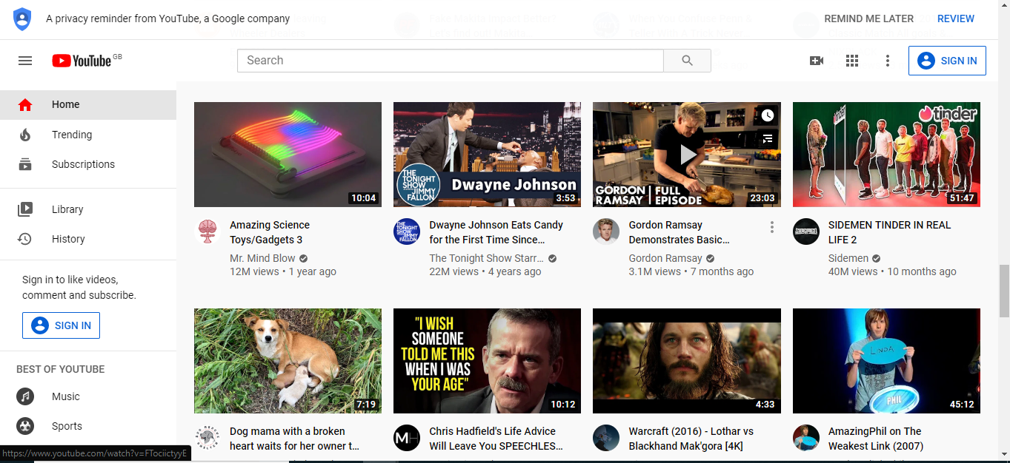

**Explain the purpose of this website:**

To entertain people, to promote and advertise products.

**Explain the target audience of this website:**

Everyone, the variety of videos allows anyone to use the website and find what they need or something that interests them. The are videos made for children, trailers for video games or films, clips of tv shows or films, tutorials on how to do things like cook, paint, draw, etc.

**Explain any accessibility features:**

The are different applications for different devices, website, mobile, tv, games consoles. Some videos also have subtitles for people who require them, as well as the video being able to be played at multiple speeds and sizes for if it is needed.

The mobile versions also allow use of the device’s accessibility features.

For iOS, the are features for blind people like screen reading, people who have difficulty using the touch screen can control the app with their voice. For people who have trouble reading or writing, the are many features to help like predictive text for people with dyslexia, or the ability to speak what you have said so you can hear how it is said and what, if anything, is wrong with the text.

On android, you can read the screen or change the font, size, colour of text on the screen, magnify the screen, or change other colour modes like invert colours or dark mode if you have difficulty seeing or reading. If you need help using the screen, you can control the device and the app with your voice, with a keyboard or switches. The are subtitles, hearing aid support, and on some devices, the ability to use speakers to amplify audio of videos, and ambient noise if required, by using external speakers.

**Explain the content and all the good features of this website:**

The website allows anyone, that has created a free account, to post whatever videos they want, as long as they conform to YouTube’s policies. This means that the is a wide variety of videos made by a wide variety of creators so the is a video on almost anything.

The website also has the ability to allow users to subscribe to channels, this allows you go to a specific section of the website and see all the recent videos by people you are subscribed to. The is also the ability to like, dislike videos and comment on videos allowing the creator or other people watching to express their opinion on the video and the comments can provide extra information or more detailed opinions on a subject.

The is also quite a range of accessibility features for the mobile versions of the websites but not many for the website version.

**My opinion on the website:**

Personally, I really like the website as it allows anyone to share their opinion or creation with a lot of the world, for free. This also allows people to find help on obscure topics they may not have been able to do before.

**2nd chosen website**

**BBC News**

News website

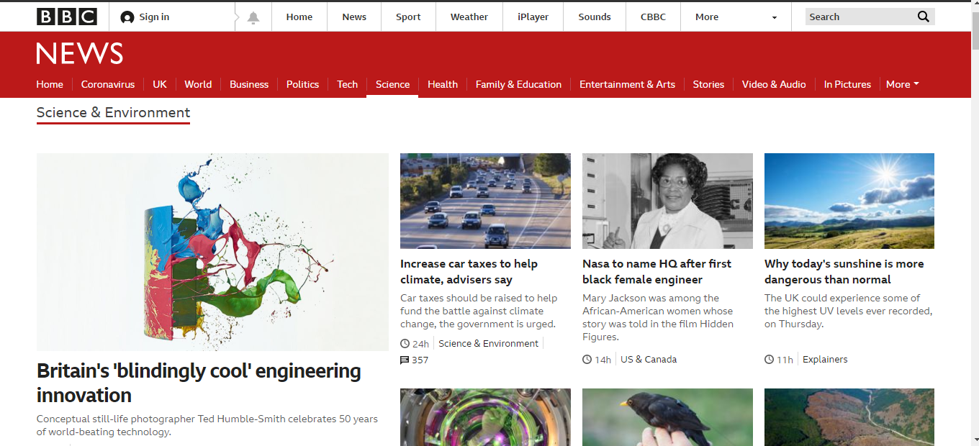

**Explain the purpose of this website:**

To inform people about events and news that are taking place in the world at the time.

**Explain the target audience of this website:**

Anyone interested in the news but mostly adults.

The audience could be anyone as the news format is easy to understand and still informative. On average the audience would be 14+ as younger children are not usually interested in world news. Teenagers can use the website but will not be affected by it as much as adults.

The layout and design of the website does not single out a specific age group as the target audience allowing the website to be used by all.

**Explain any accessibility features:**

It has a mobile application and the news can be read on smart speakers.

The are accessibility features, they are split into categories such as if you can’t see very well, which is different to the section for if you blind, if you are hard of hearing, or you find words difficult, or find using a keyboard and mouse hard to use. Within these categories the are specific options, for example in the “I can’t see very well” category, the is options for changing the font colours and background colours, changing the font, magnifying the screen, getting the computer the read the text, change font size, and it has links to products to make the keyboard keys easier to read. The website has a similar amount of accessibility features for all of its categories. These features help use the website even if you have a wide range of disabilities.

**Explain the content and all the good features of this website:**

The website has easy to navigate menus with specific sections for UK, World, Business, Politics, Tech, Science, Health, Family and Education, Entertainment and arts. This makes it easy to find the category of article you are looking for. The is a search bar that allows you to search for specific articles. This allows for quick and easy navigation of the website.

The articles have images and contain detailed descriptions of the subject they are talking about. The articles are mostly not long but there are specifically long articles. Both types of articles contain the same level of clarity, detail, and information.

**My opinion on the website**:

The website is good and informative, the articles are well written and informative although it is hard to find hard older articles which would be a nice feature to add but they are still on the website so it is possible to find them.

**3rd chosen website**

**BBC Bitesize**

Education website

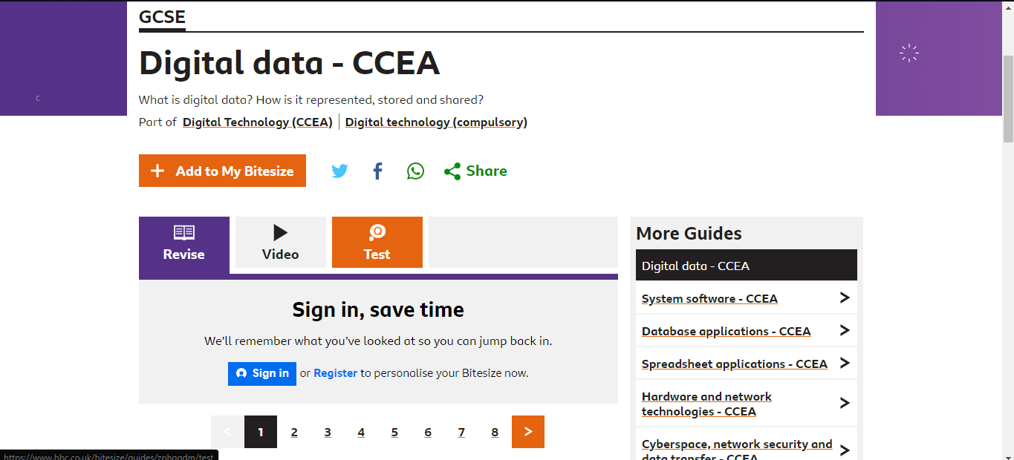

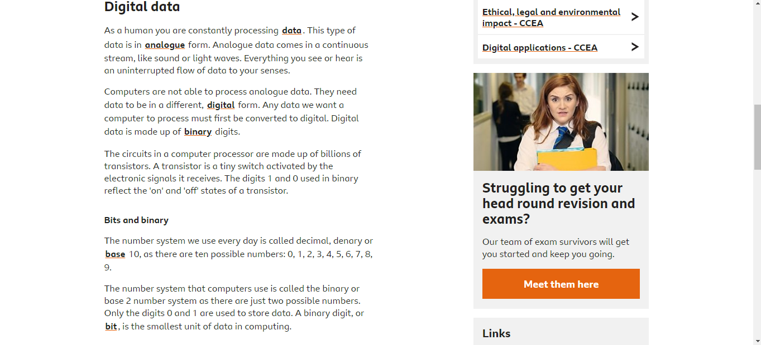

**Explain the purpose of this website:**

To educate children between the ages of 3 – 16+

**Explain the target audience of this website:**

People between the ages of 3 – 16.

**Explain any accessibility features:**

Videos can have subtitles or sign language

The is easy to use and easy to find the specific section that you want to learn about due to easy to use menus and other navigational features like a search bar.

The are accessibility features, they are split into categories such as if you can’t see very well, which is different to the section for if you blind, if you are hard of hearing, or you find words difficult, or find using a keyboard and mouse hard to use. Within these categories the are specific options, for example in the “I can’t see very well” category, the is options for changing the font colours and background colours, changing the font, magnifying the screen, getting the computer the read the text, change font size, and it has links to products to make the keyboard keys easier to read. The website has a similar amount of accessibility features for all of its categories. These features help use the website even if you have a wide range of disabilities.

**The content and all the good features of this website:**

The are links to other website and there are extensive pages of information and images on many subjects (at least 36 subjects, 4 exam specifications, for GCSE in England alone. This makes it a good tool to help revision and learning about the specific chosen subject whether that be GCSE Biology or year 6 maths. The wide audience and subjects make it usable for lots of children and teenagers in the United Kingdom.

**Personal opinions:**

It is easy to use and navigate. The pages are detailed, contain videos and images to help educate people. The are tests to help make sure people have learned the topic, all these features make it a useful website for teaching and educating people

**4th chosen website**

**Amazon**

E commerce website

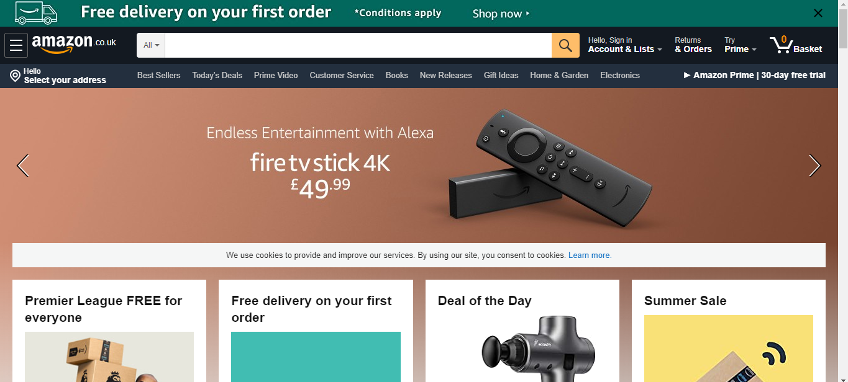

**Explain the purpose of this website:**

To sell products whether that be a physical product like a phone, book, or a jumper, a subscription to a service like amazon prime or kindle unlimited, or buy electronic products, like audiobooks or eBooks.

**Explain the target audience of this website:**

The target audience is anyone who wants to order a product from amazon. The are a wide range of products that can be bought including a wide range of physical products including clothes, electronic products, books, children’s toys, or food. You can also buy electronic products like subscriptions to one of amazon’s services like amazon prime, or kindle unlimited, these services offer features like access to a streaming service, discounts, and free next day delivery on curtain products. Other products include audiobooks, and eBooks. The wide range of products makes the target audience wide as a wide variety of people would want to buy the product.

**Explain any accessibility features:**

The website has a mobile version for people who find it easy to access it there. The is also a website plugin allowing for zooming in on text, changing text size and colour, text to be read to the user, and some videos have subtitles to help with visually impaired people.

The is an easy to navigate menu allowing people to view specific products based on what category they want (children, electronics, books, etc.), as well as a search bar to help people find the specific product they were after. This makes navigating the website relatively simple and intuitive.

**Explain the content and all the good features of this website:**

Due to the wide range of items for sale on the website and the easy to use navigation, the website can be used by most people allowing them to buy what every they realistically might want for a not unreasonable price.

The time between order and delivery can be as low as hours and are not usually over 5 days to arrive within most areas within UK.

**Personal opinions:**

I think it is a very useful website to use for online shopping as the shear variety of products makes it easy for you to find whatever you are looking for. This joined with the low times to deliver packages can allow you to get a quite obscure product for a reasonable price in as low as a few hours. The connectivity of amazon services makes it easy to use and jump between services, for example if you buy a book on amazon to have delivered to your house, you will sometimes get an electronic copy so you can start reading straight away and you don’t have to wait for the product to arrive.

**Website comparison**

All the websites are well suited to their different purposes. And I have previously expressed my opinions on each in their respective sections but I believe the websites made by the BBC are the best accessibility feature wise as the range of options, the ease of being able to change them and the well laid out page leads to the page being easy to use for everyone although YouTube has a wide range of options available, like BBC’s websites, for people who are hard of vision, people who are hard of hearing, or people who cannot use a keyboard and mouse very well, allowing the website to be used by all but they are not very specialised to the website and they are hard to find whereas BBC’s features are easier to find and easier to use.

[1] <http://www.bbc.co.uk/webwise/guides/what-is-the-internet#:~:text=The%20internet%20is%20a%20global,small%20packets%20of%20digital%20data>.

[2] <https://www.bbc.co.uk/bitesize/topics/zkcqn39/articles/z2nbgk7>